MATH 1232 Summer 2006 Dr. McLean Name _________________________________

- The disability rate in percent for people over 65 years old is R(t) where t=0 means the year 1982.
- What was the disability rate in 1982?
- What was the rate in 2008?
- How fast was the rate changing in 2000?

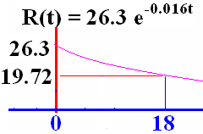

2. Find absolute extrema of f(x) = (x²-4x+3)³ on [-1, 2].

- Write the equation of the line tangent to the graph of f(x) = 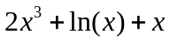 when x = 1.
4. The number (in millions) of Yahoo households in W. Europe is N(t)=34+24 ln(t+5) where t = 0 is 2004.
a) How many W. Eupopean households used Yahoo in 2005?
b) How fast was the number of households rising in 2005?
5. Find the derivative of f(x), if
a) f(x) = 5x⁴ - 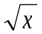+ 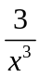, and
b) f(x) = 2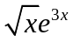.

6. a) Solve the equation for x. 8^{3x − 2} = 8^{2x + 3}

b) Express the equation in logarithmic form.
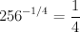

c) The temperature of a cup of coffee t min after it is poured is given by the following equation where T is measured in degrees Fahrenheit.
(i) What was the temperature of the coffee when it was poured?
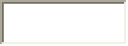°F
(ii) When will the coffee be cool enough to drink (say, 120°F)? (Round your answer to one decimal place.)
min
(iii) How fast is the temperature changing when t = 10?

7. A Bulloch county farmer has 8000 feet of fence to fence off 3 sides of a rectangular piece of land along the straight Ogeechee River. If the river is the fourth side of the rectangle, what is the largest rectangular area that can be fenced?

8. Differentiate y = 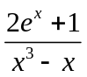

9. If an investor wants her $13000 to double when compounded continuously at 7%, how many years will she have to wait? ( Recall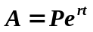 )

10. How long will an investor need to leave her $5000 in a bank that pays 3% interest, compounded semi-annually, before she has $7000.

11. Evaluate 

